**What level of AWS, Azure or GCP expertise is required?**

Basic level only cloud storage services (AWS S3, Azure Blob storage and Google cloud storage) will be used primarily for data storage and that will be covered as a part of this training

**Snowflake Purpose**

Snowflake is Ideal for below purposes

Snowflake is a fully managed SaaS (software as a service) that provides a single platform for data warehousing, data lakes, data engineering, data science, data application development, and secure sharing and consumption of real-time / shared data.

* **Data WareHouse (primary)**
* **Data Lake (primary)**
* **Lakehouse**
* Data Exchange
* Data Apps
* Data Science
* Data Engineering
* UNISTORE (recently announced, can be used as OLTP with Hybrid tables)
* CYBERSECURITY WORKLOAD (recently announced)

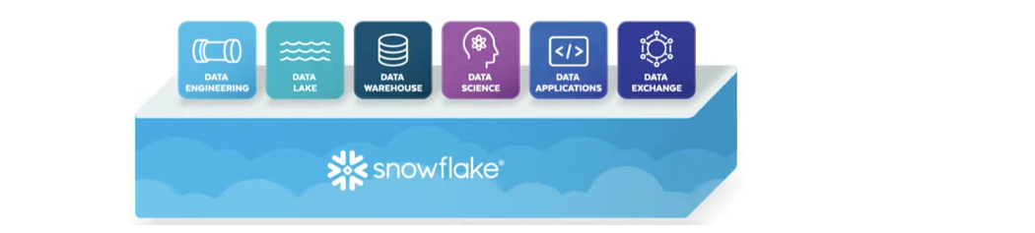

**Relational Databases (RDBMS)** (Oracle, SQL Server, MySQL, PostgreSQL…)

#### Relational databases are designed to run on a single server in order to maintain the integrity of the table mappings and avoid the problems of distributed computing.

**Shared Disk Architecture**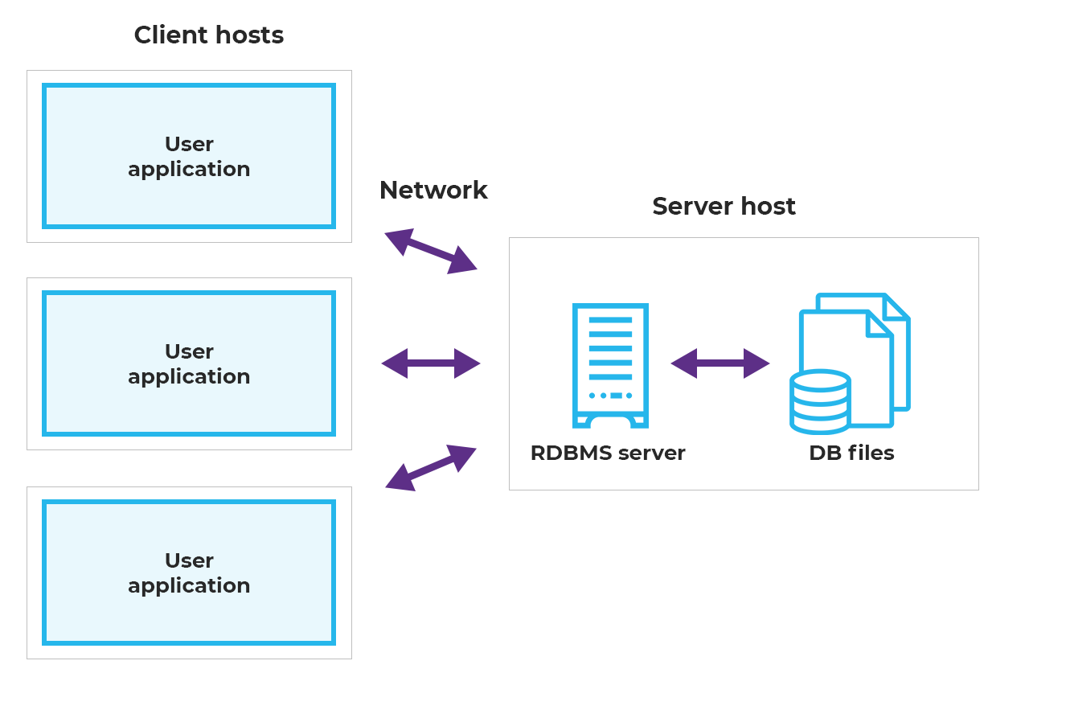

**Scaling vertically** ===> One big machine will do all the work for you.

**Scaling horizontally** ===> Thousands of machines will do the work together for you.

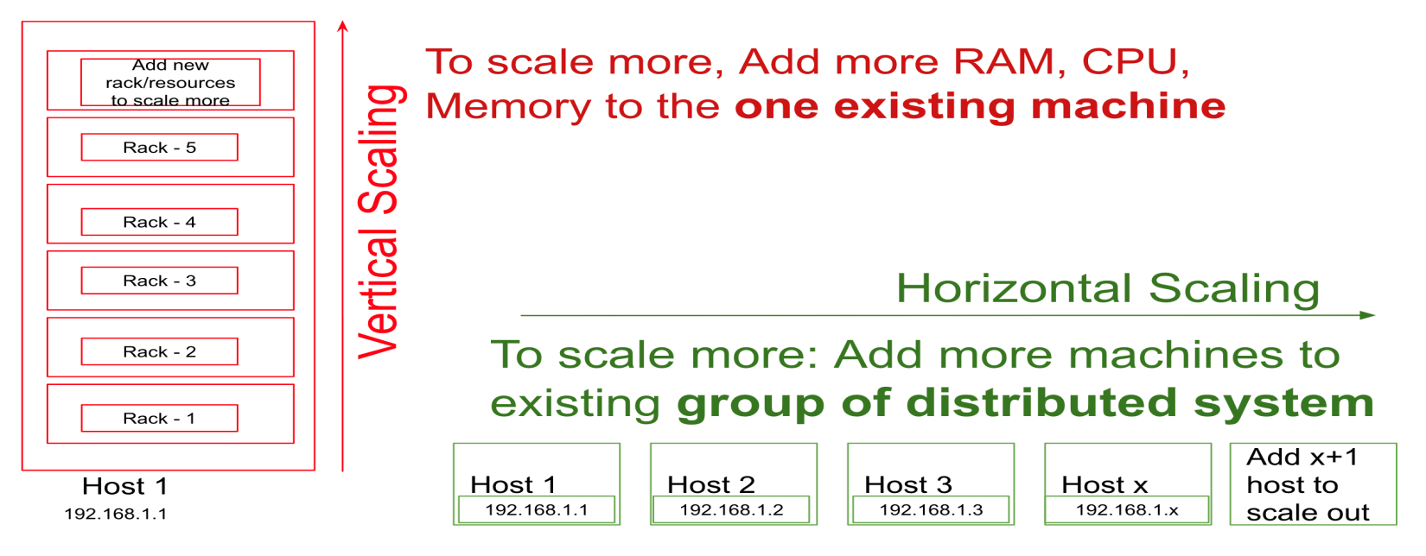

RDBMS can be scaled vertically but not horizontally

In order to run a query on a database it would require compute resources like Processor, RAM

**If Data volumes/users increase we will have to face performance issues since there is limit to scale a machine/computer vertically.**

**Limitations of relational databases**

1. **Scalability, performance and speed**
2. Licensing cost and maintenance over head
3. Concurrency issues (can’t handle large number of users at a point of time)
4. Limited/No support for Semi structured and unstructured data
5. Database Failure
6. Up gradation Costs